Creating A User Profile
- To access in to the company profile, each and every person who use the system needs a user profile to work on this system. Here are the guide lines to create a user profile.

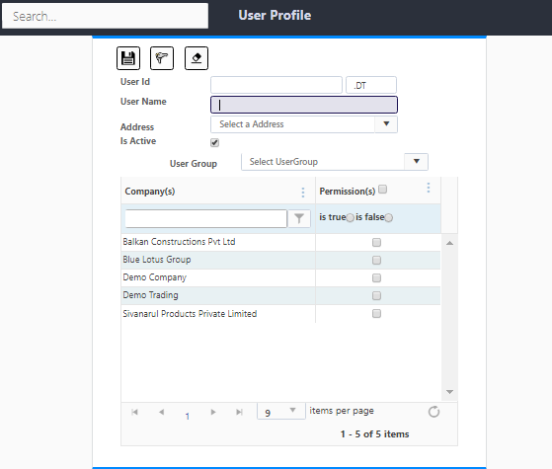
Guidelines to create a user profile

- Type a user Id given column. (Ex: Normally select your name) Please have a mind of the second column along with the first column. It is going to use later when you logging again.

- Type a User Name

- Select the Company and tick the box according to the company.

- After finishing the process press the save button.

- Then Log out from the system.

Second Process

- Log in again using user id given by the user.

- System automatically will give a password to log in to the system. (0000 is the temporary password for every new user)

- Create a new password with maximum eight characters, one each with uppercase letter and lowercase letter and a number.

- Then the new user can log in with the system with new password.

