Item Creation

Item Entry
Setup
Trading Items
Inventory
Item

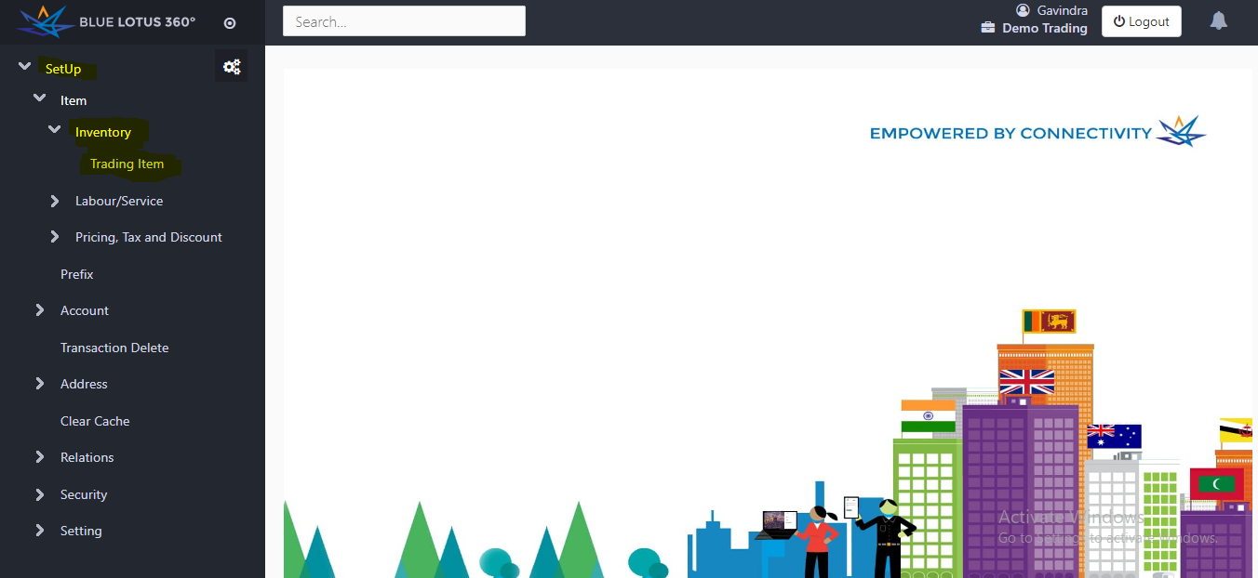

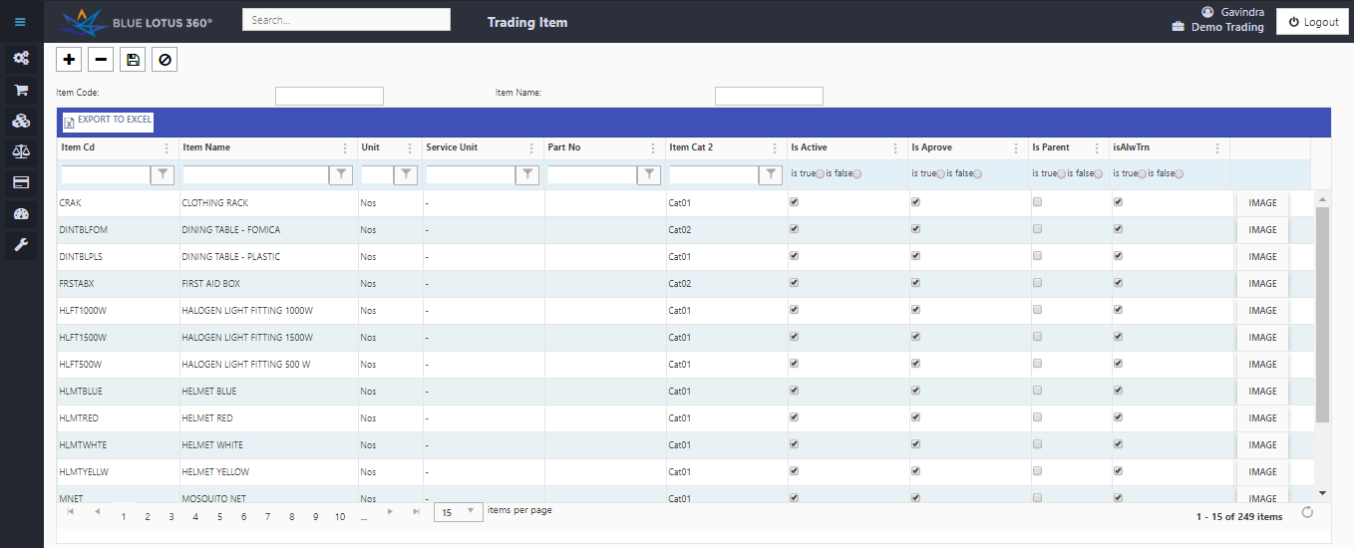

Information

Element | Feature
Item code | Create an item code for the product. ( Maximum 15 characters Only)
Item Name | Enter the name of the item.
Unit | Name the measurement of the product. (eg: Nos, ml and etc.)
Is Active | Choose whether the item active or not.
Is Approve | Choose whether the item approve or not
Is Alw Trn | Define whether that the item shown in transactions forms or not.

- Press + button to create a new column to enter new item into the system.

- You can enter all your products in an Excel sheet. We have a specific template to enter items in a excel sheet. So later you can upload information into the system.

- After entering an item, also you can upload an image in to the system.

- After entering the item press the save button.

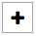 New Add row button

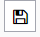Save Button

