Item Creation

Service Entry

Item
Services
Labour/ Services
Set Up

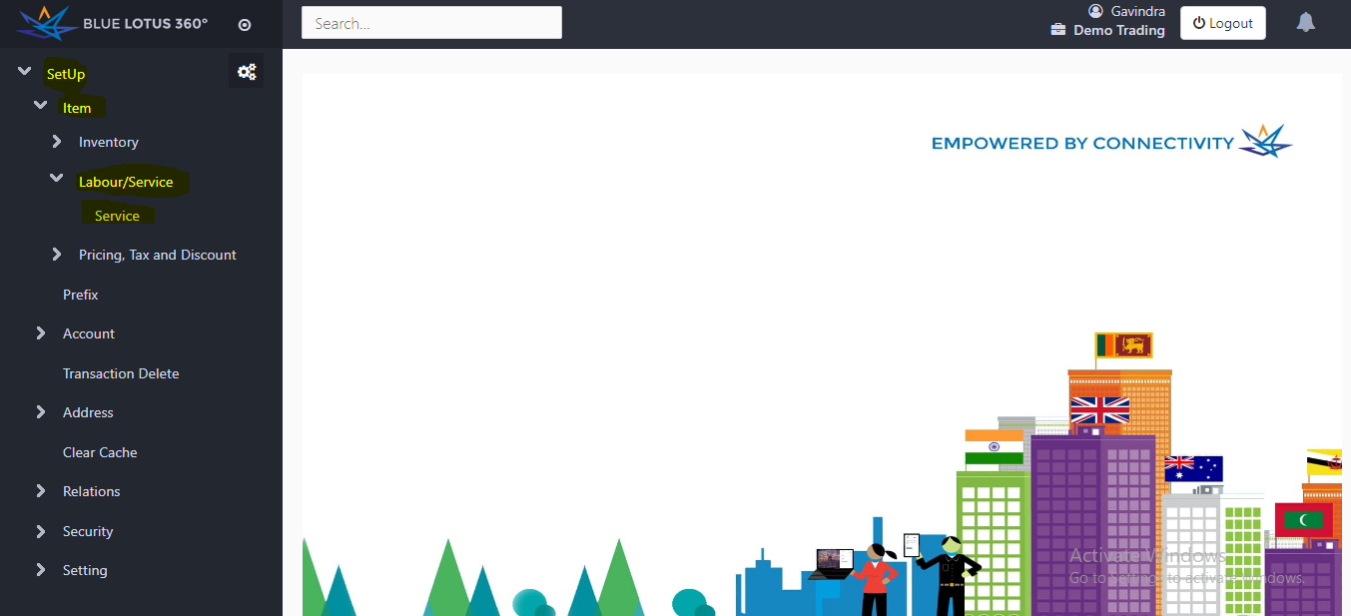

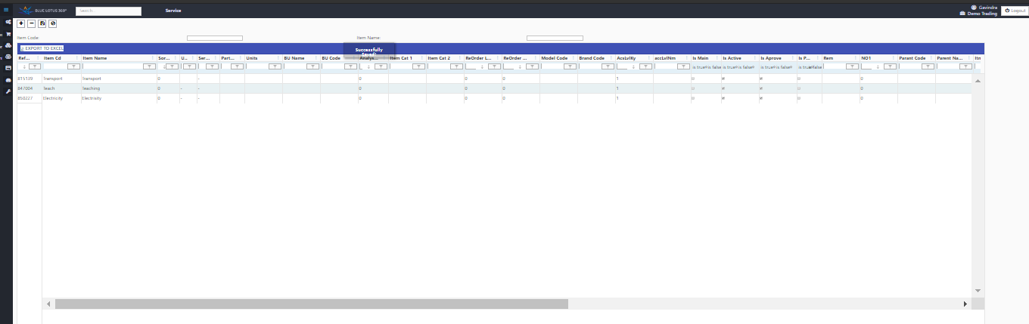

Information
Element | Feature
Reference Number | Automatically this will create in the system.
Item Code | Create a code for the service that you going to provide.
Item Name | Name the service you going to provide. (ex: Transport, Teaching)
Service Unit | Add the Unit of measure.
Is Active | Choose whether the item active or not.
Is Approve | Choose whether the item approve or not
Parent Name | Name the Parent account that this service appears on the system.
Is Alw Trn | Define whether that the item shown in transactions forms or not.

- You can enter all your products in an Excel sheet and import into our system through this service entry format.

- After entering a service, also you can upload an image in to the system.

