Chart of Accounts

Whether you have an accountant in your internal team or you do it yourself or you have chosen to outsource it, the financial accounting process is almost always at the center of any business management system. In Chart of Accounts we are adding receivables, Payables, Expenses and Fixed Assets.
To Start with the Blue Lotus 360 you need to create accounts through Chart of Accounts and get start with the ERP. For each Company, the master for Chart of Accounts is maintained separately. This allows you to maintain separate accounting for each company as per the legal requirements.

Setup

Account

Chart of Account

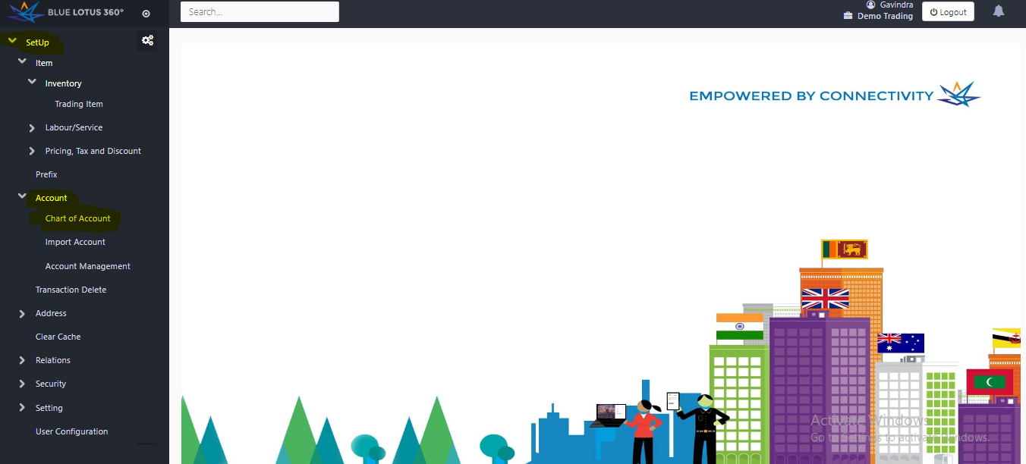

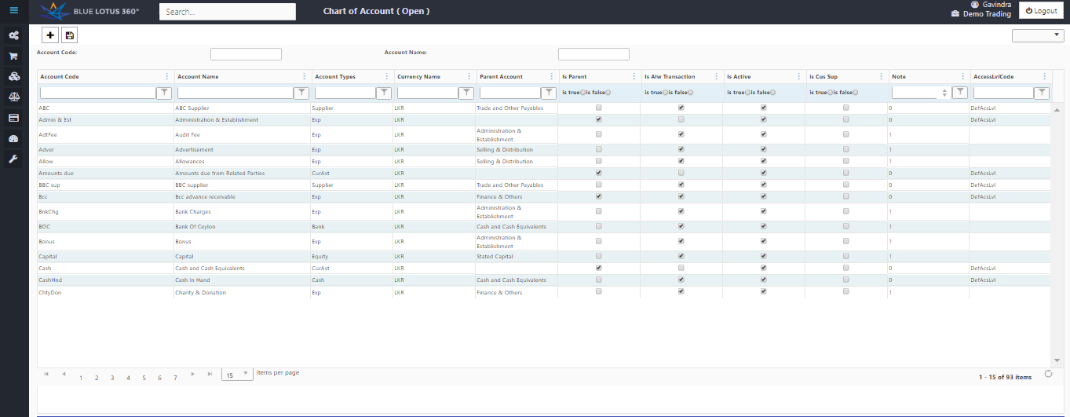

Information
Element | Feature
Accounts code | Choose an account code for the account. ( Maximum 15 Characters Only)
Account Name | Type the Account that you want to create.
Account Type | Name the Account type (eg: Current Asset, Expense, Supplier and etc)
Parent Account | Name the Parent Account it belongs to.( eg: Admin, Sales, Finance and etc.)
Is Parent | Choose the account that it is parent or not.
Is Alw Transactions | Define whether the account shown in transaction forms or not.
Is Active | Choose whether the account is active or not.
Note | Use the column to put financial notes.

- Press + button to add a row to create a new account.
- After filling the necessary columns press save button.

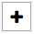New add row button
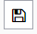Save button

