Multi-Approval
BLUe PRINT
2020

Multi-Approval Flow Chart
| BLUELOTUS360 PVT (LTD) |

Multi-Approval Cash Flow Chart

Step 01- Select the “Trntype” and Un tick “Auto Approval”

As a first step in Multi-Approval, User has to decide the Form/UI/window for which he/she is going to apply Multi-approval.
Next, user has to Pick the decided transaction type in the Transaction Types (Trantype) under Add/Edit code.

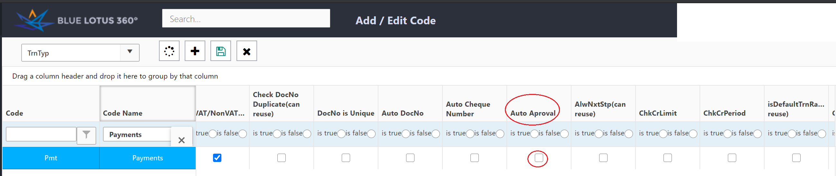

Step 02- Select the AprSts and tick “IsAprSts” For the relevant Approval stage
Next, user has to Create the Approval Statuses (AprSts) in the Add/Edit code.
User clicks the “+” icon and creates the approval statuses.

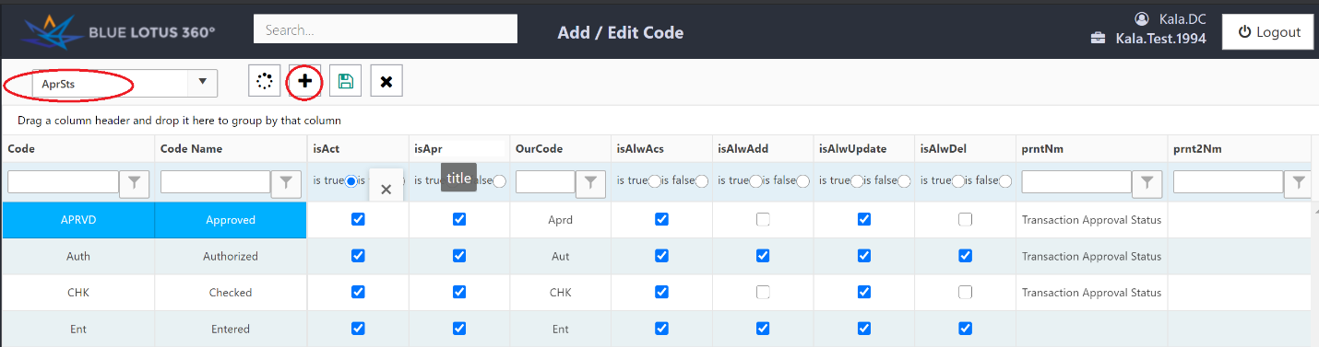

Step 03- Select a user in user permission
Next, user will go the User Permission Window/UI, and open up the UI. When he opens the UI there will be a grid with Active Users in the System.
User has to pick users in the grid to allocate the Multiple Approval.

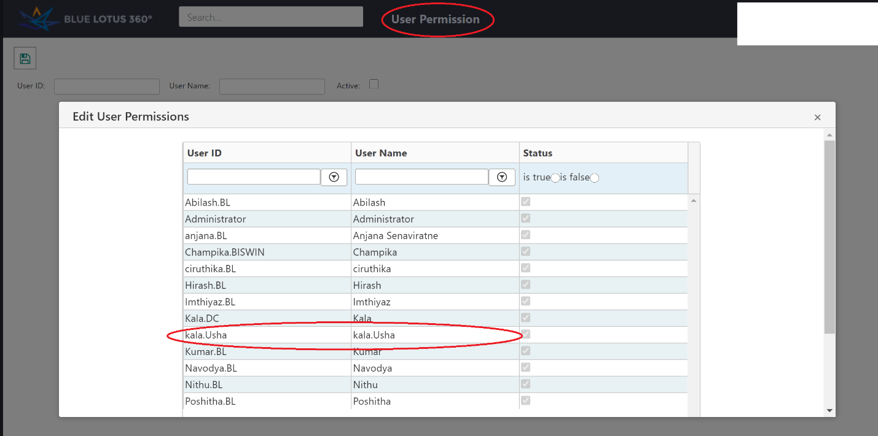

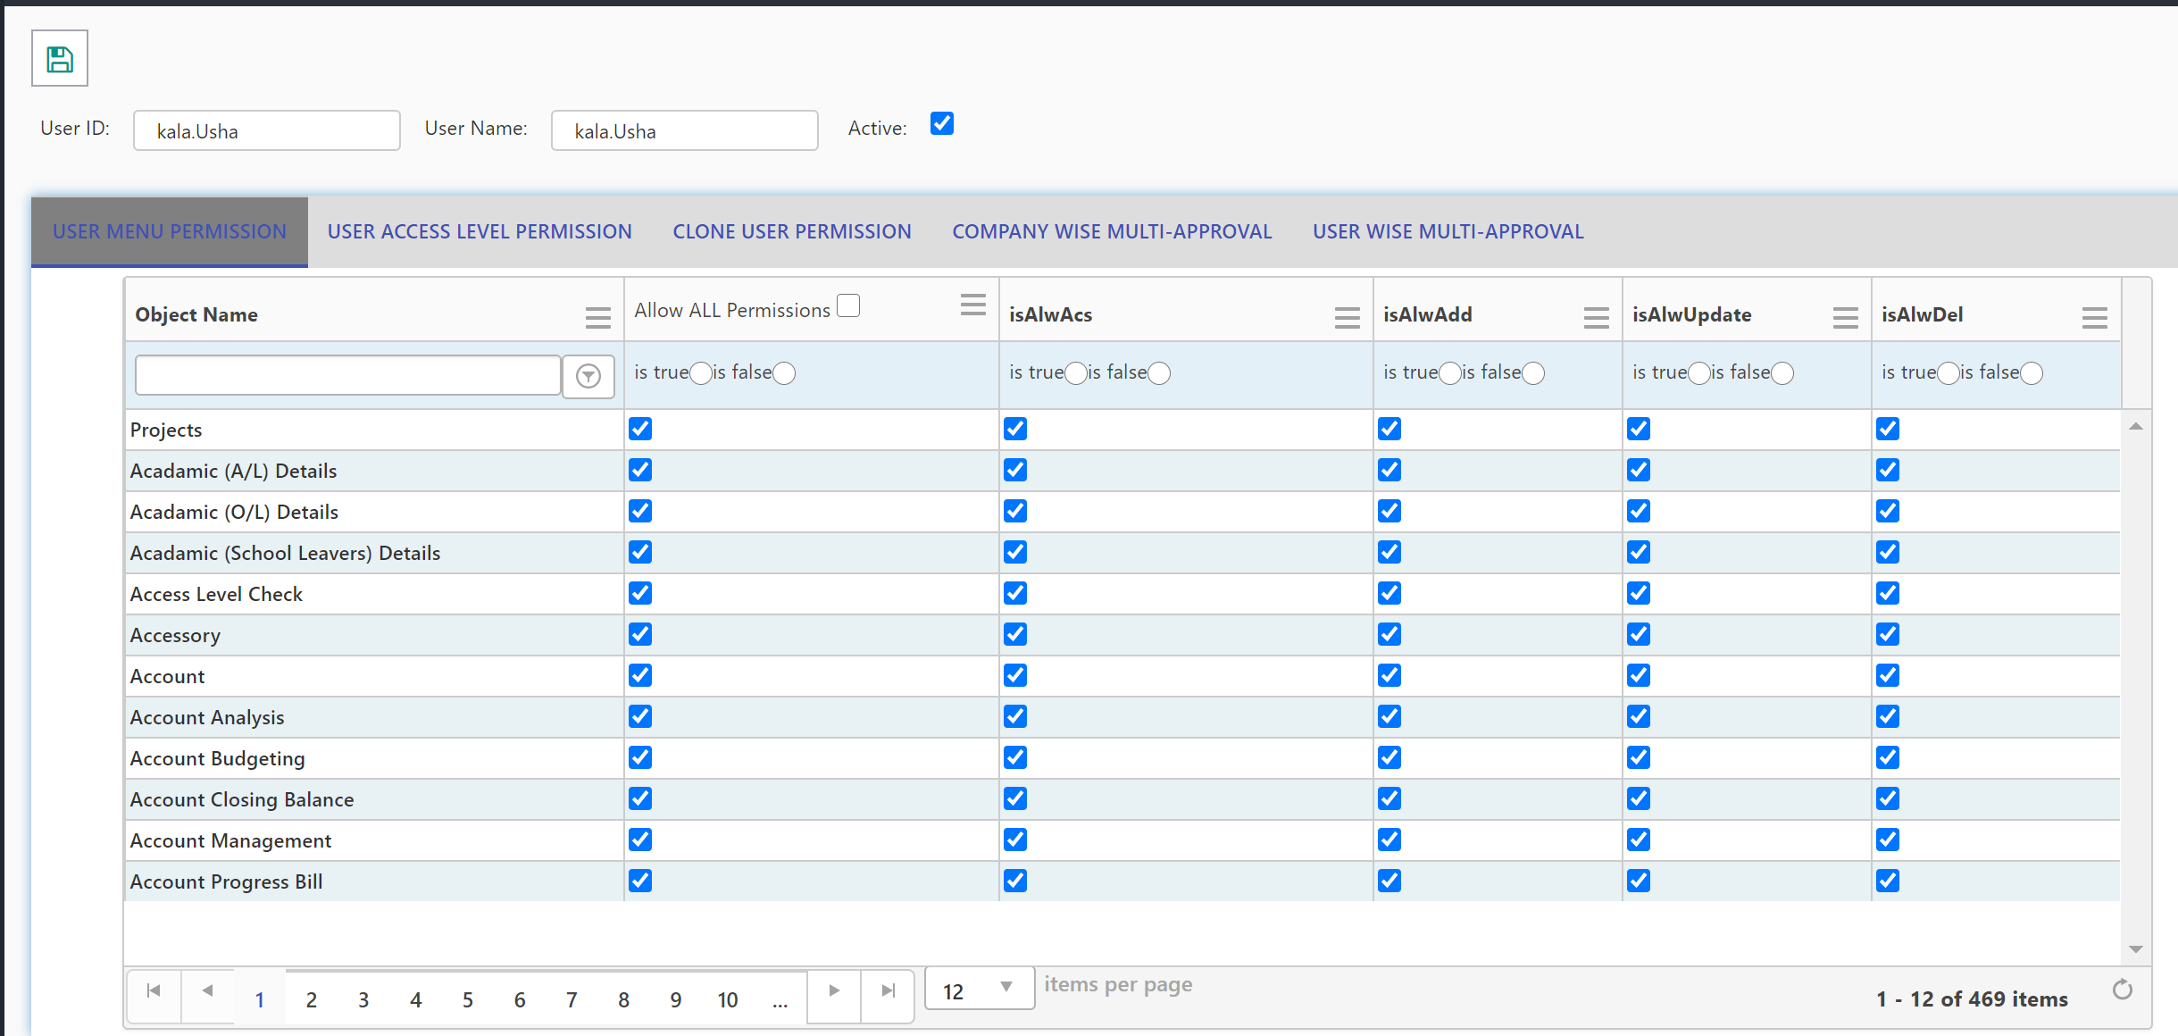

Step 04- Select the Company Wise Multi-Approval tab

User will click the “Company Wise Multi Approval” tab and select the UI/Window for which user going to apply Multi-Approval.

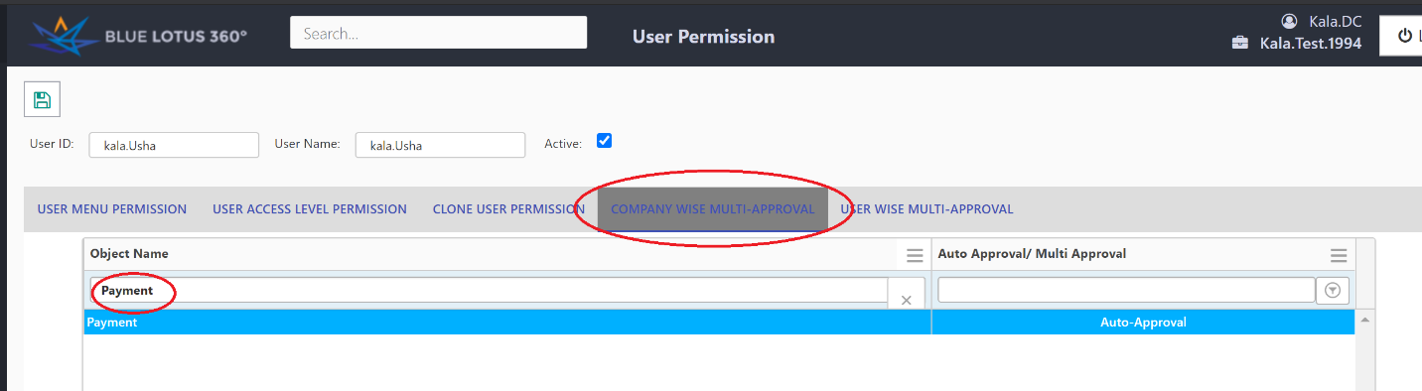

Step 05- Select the Approval Levels
Once User selects, the UI/Window and double clicks the “Auto Approval”, there will be pop up with the Approval Statuses. Where user picks relevant approval statuses which are needed for that relevant UI.

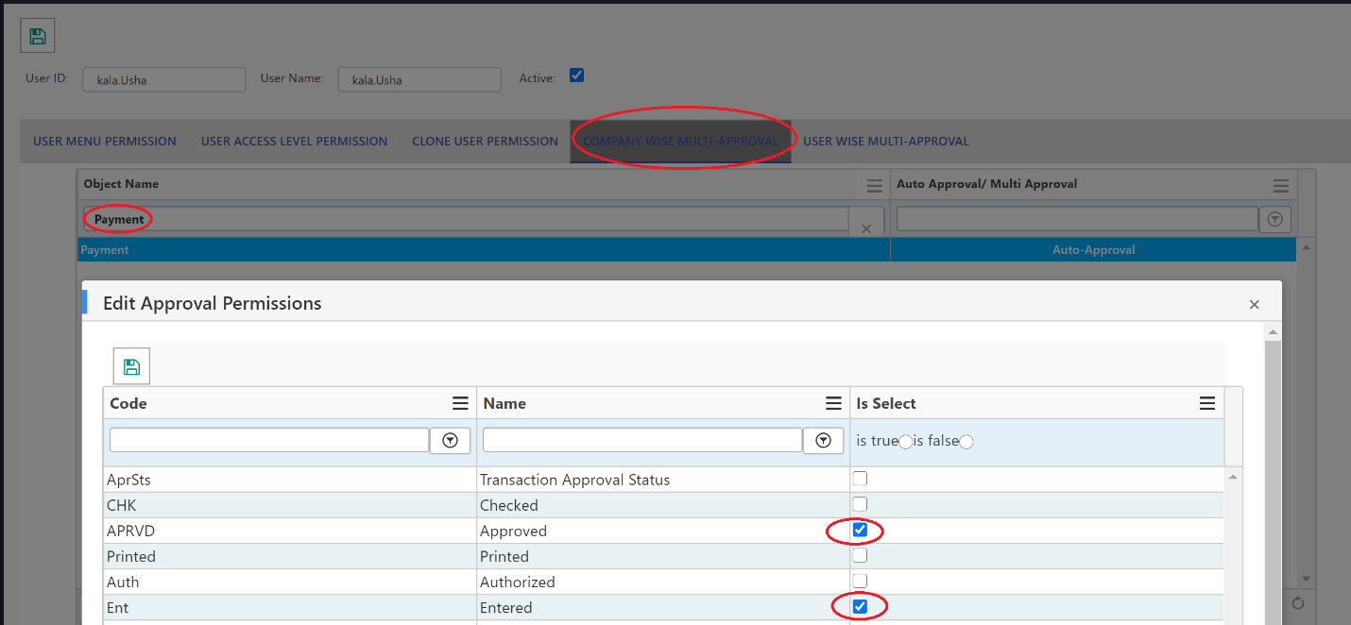

Step 06- Select the User Wise Multi-Approval tab
After selecting the relevant approval statuses for the relevant UI, User selects the User Wise Multi-Approval tab.
User loads the relevant UI and assigned the relevant approval status for that particular User.

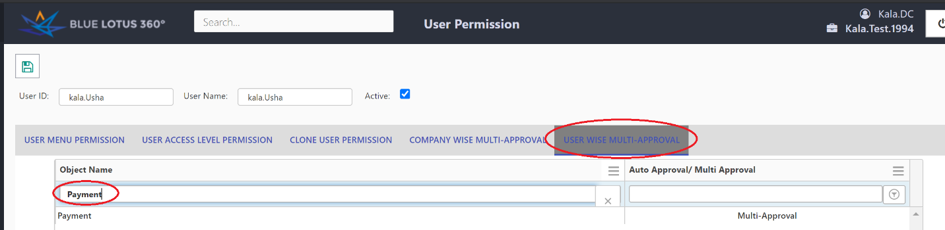

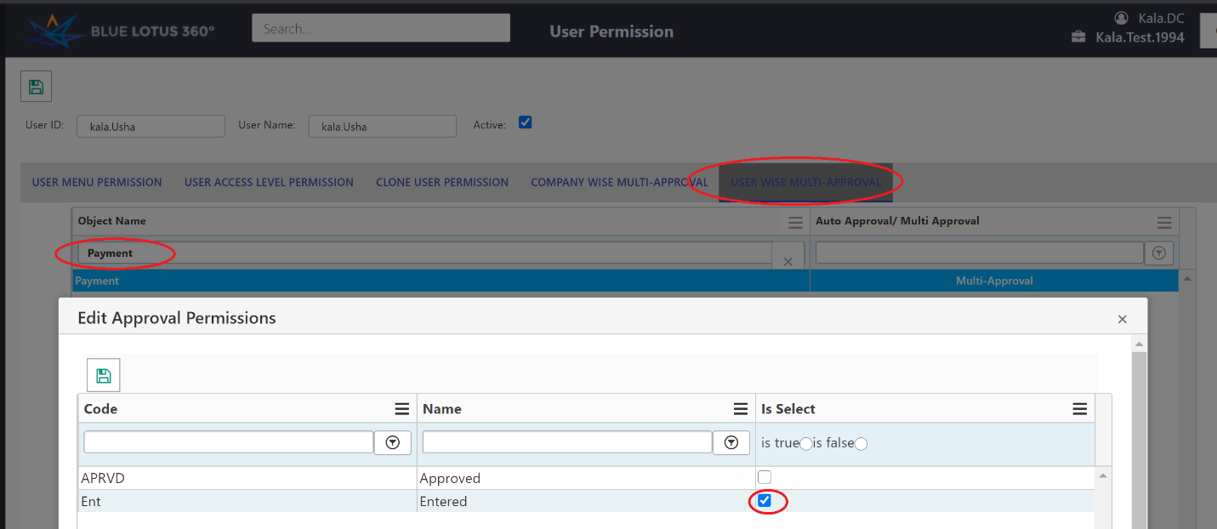

Step 07- Raising transactions

Data Entry
When a User with entered approval permission raises a transaction, it will be saving as draft. There won’t be any accounting impact and will not get posted on Reports. Document status will be entered.

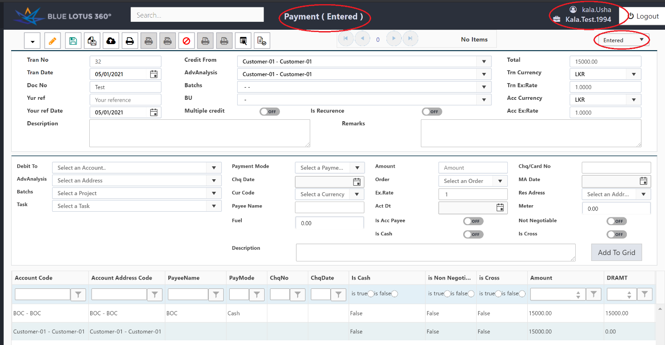

Data Approval

Method 1

When a User with “Approved” approval permission for that UI/window, once he/she approved the transactions it will be saving as a real transaction and it will be added in the ledgers and get posted on Reports. Document status will be Approved.

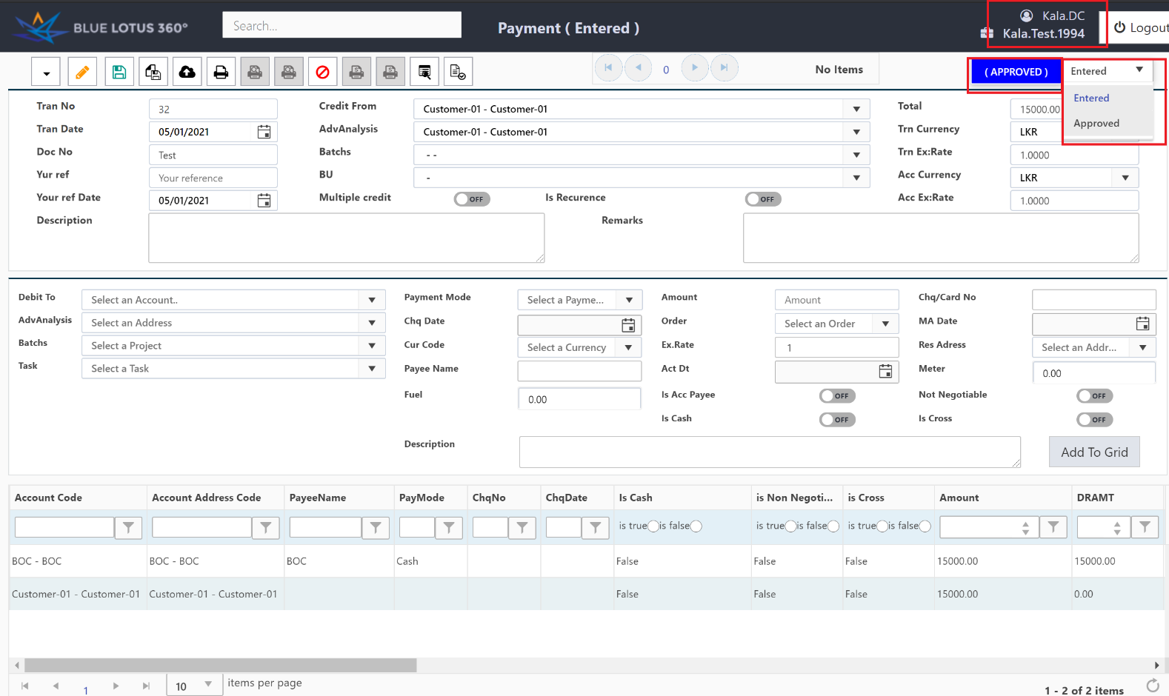
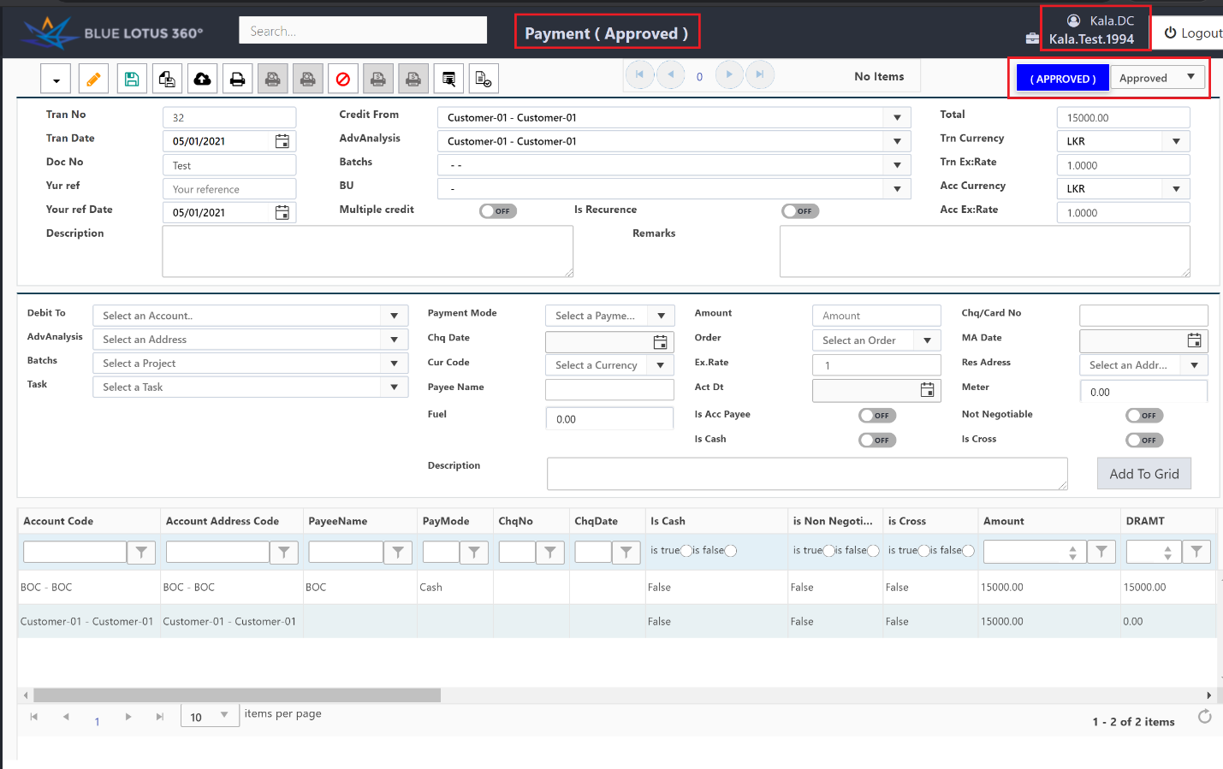

Method 2

An authorized user can go to approval status Update and filter the transaction by AprSts and Transaction Type.

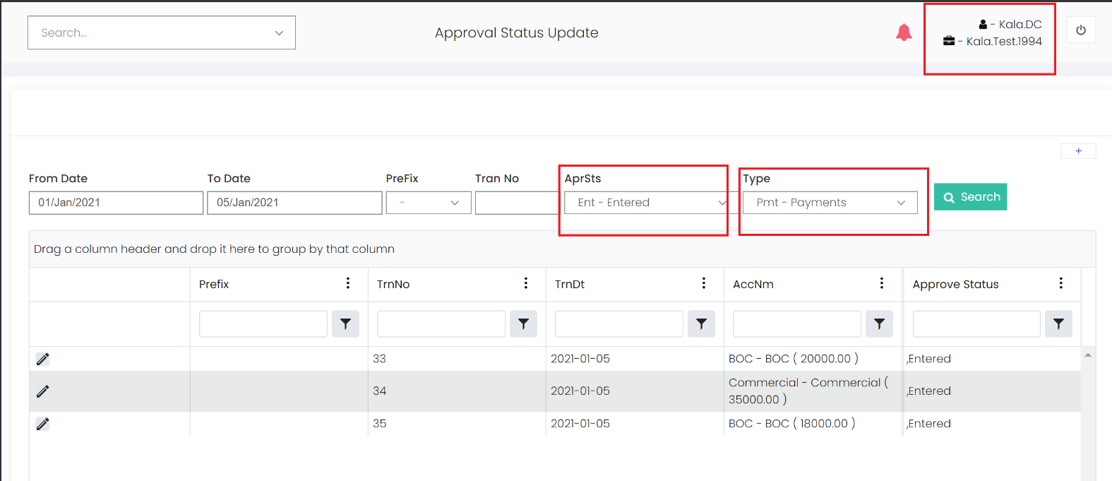

User will click the edit button and change the approval status to Approved.

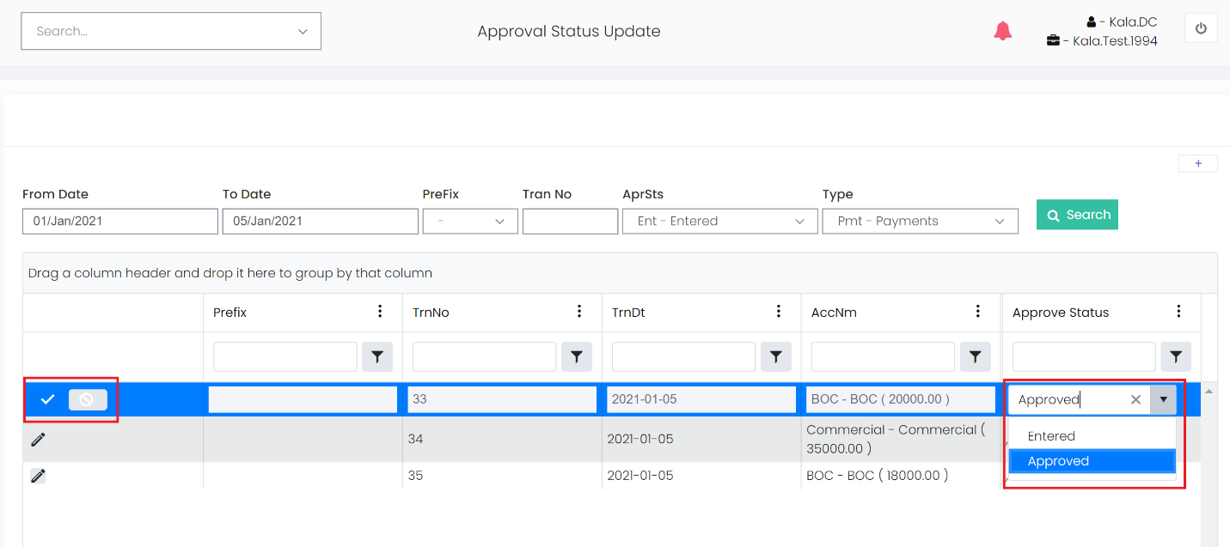

Thank You

