Cash Flow Statement Configuration
- Navigate to the Financial Statement configuration form and pick the Statement of Cash Flow Report.
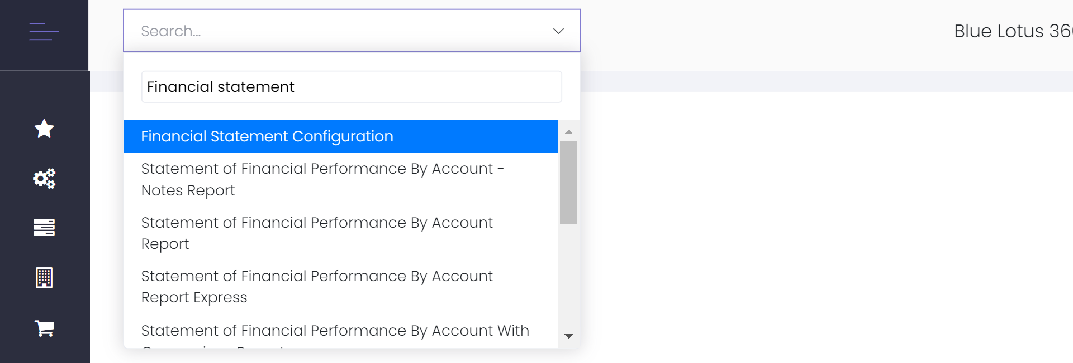
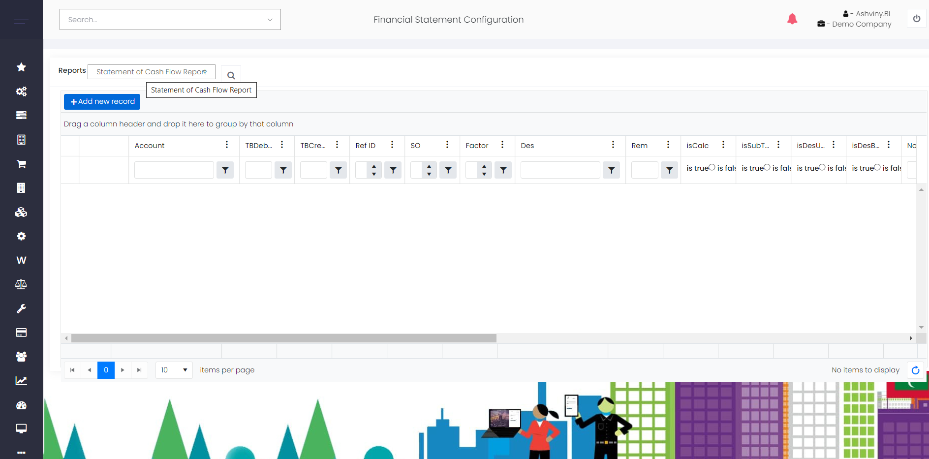
- Add New Record,
  - Account – Account balance
  - TB Debit – Debit TB Balance
  - TB Credit – Credit TB balance
- SO – Use this option to define the Sorting Order on the CashFlow Statement. Maintain a gap. Eg: 10,20,30.. so that you will be able to enter any line in between whenever required.
- Factor – ‘-1’ / 1
- Des – Enter the Line Description to be displayed on the Statement
- Is Calc/IsSubTotal – Either one of these can be used, not both at the same time.
- IsDesBold – To bold the Description
- Notes – Should you have any notes use this option to enter the number, can extract a report on notes
- RefObj – Any line from the Statement of Profit or Loss & Statement of Financial Position can be taken to the Cashflow using this option. For this, IsRefObjRptTmpl tick should be ON on the particular line of the statement.
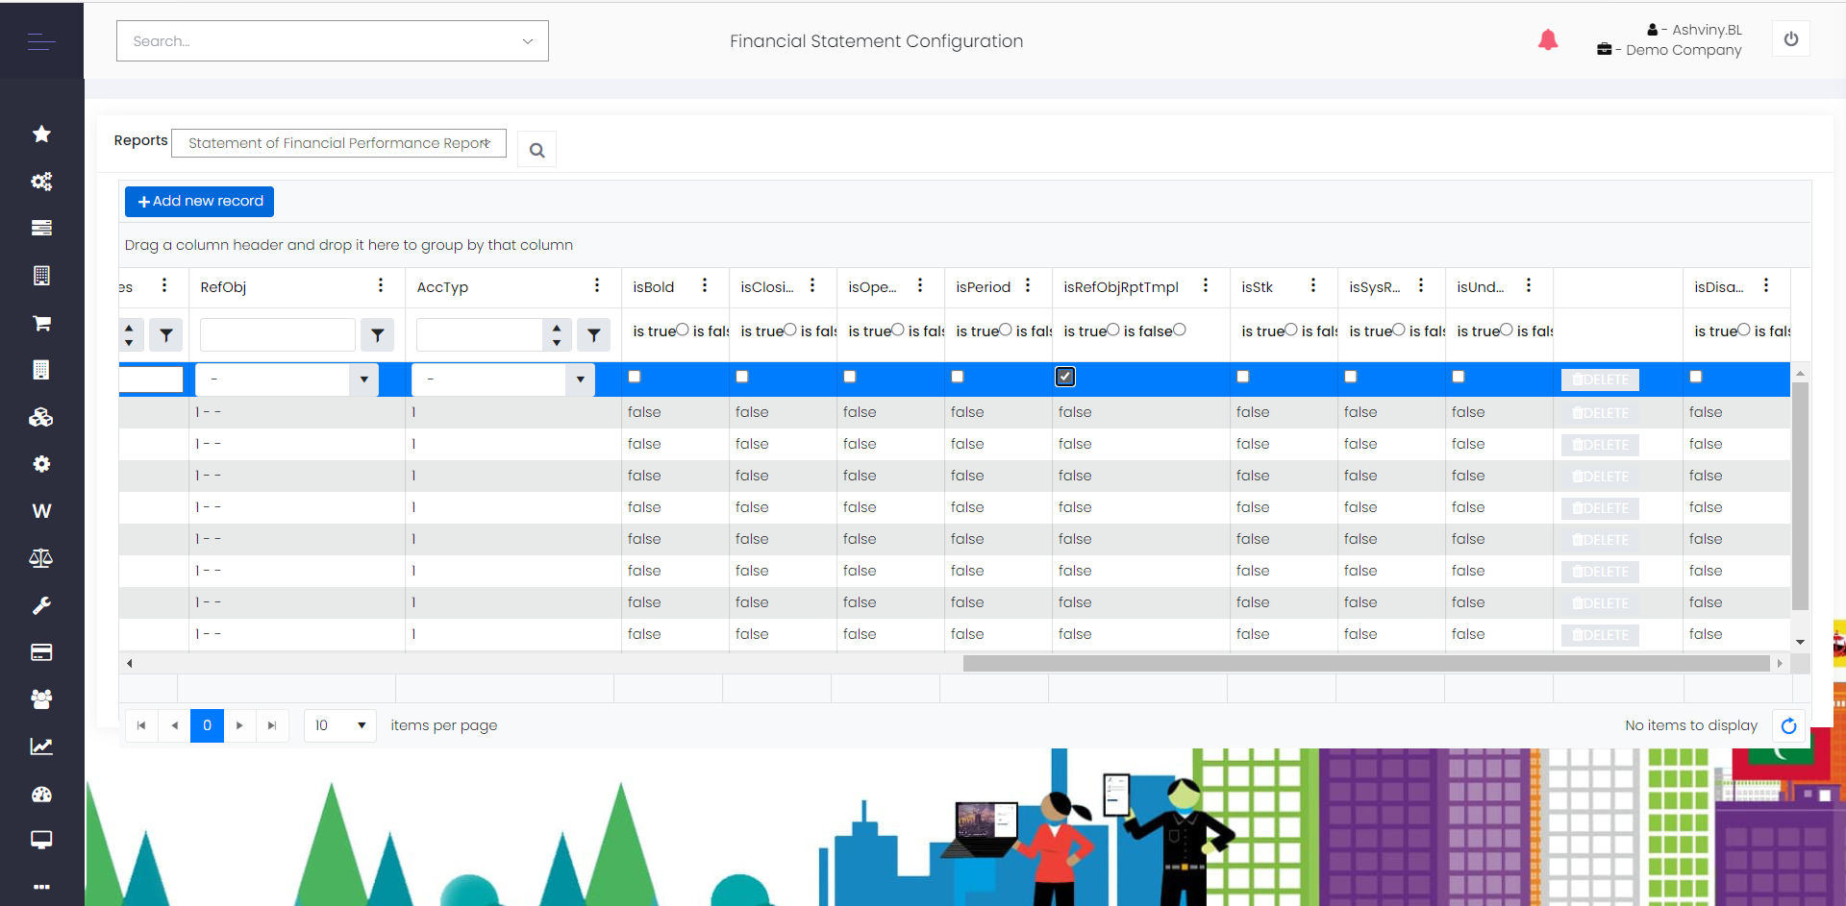
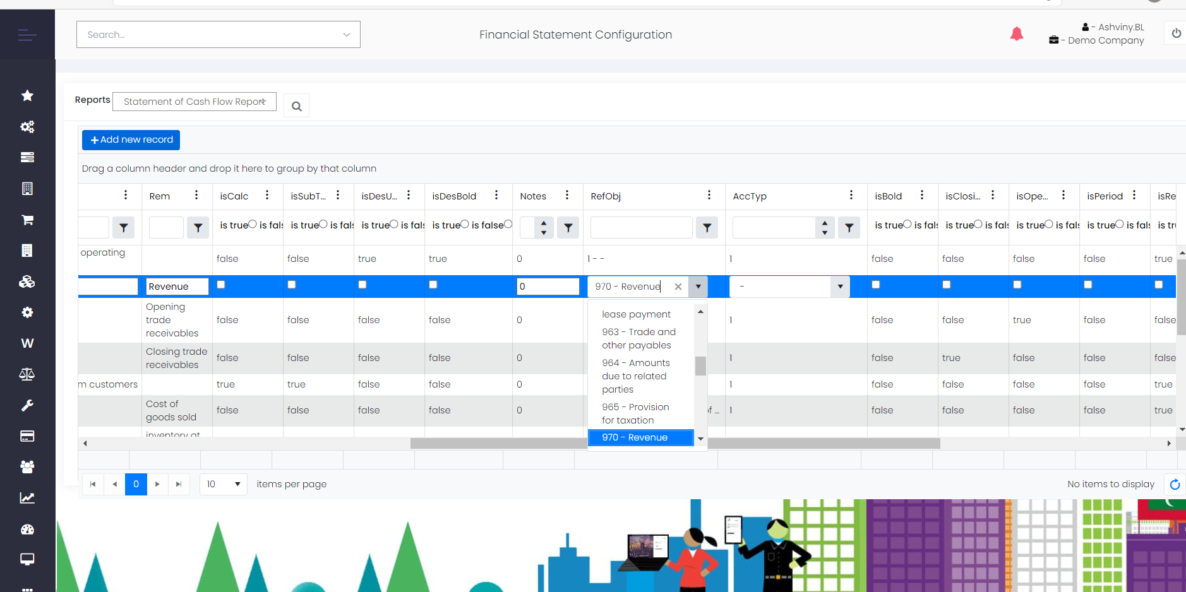

- Possibility of having up to four levels of calculations, using the Parse Option.(Parse 1/Parse 2 etc…)

